**Chapter title Minion Pro bold 16 pt.**

Author’s name 12 pt.  
*Institution of origin 11 pt. italics*

**Headline 1: 12 pt. bold (numbered)**

This template has specific dimensions and margins and is the one that must be submitted for publication in English with Peter Lang. Body text justified in regular Minion Pro 10 pt. Line spacing 1/5. The use of explanatory footnotes is allowed, provided they are considered essential for the correct understanding of the text. Call to footnote with arabic numerals[1]. The footnote must be placed just after the term to which it refers and before the full stop, or after the full stop if the annotation affects the whole sentence or idea. No courtesy line between paragraphs within the same section.

This template has specific dimensions and margins and is the one that must be submitted for publication in English with Peter Lang. Body text justified in regular Minion Pro 10 pt. Line spacing 1/5. The use of explanatory footnotes is allowed, provided they are considered essential for the correct understanding of the text. Call to footnote with arabic numerals[2]. The footnote must be placed just after the term to which it refers and before the full stop, or after the full stop if the annotation affects the whole sentence or idea. No courtesy line between paragraphs within the same section.

**Headline 2: Minion Pro bold 11. (numbered)**

This template has specific dimensions and margins and is the one that must be submitted for publication in English with Peter Lang. Body text justified in regular Minion Pro 10 pt. Line spacing 1/5. The use of explanatory footnotes is allowed, provided they are considered essential for the correct understanding of the text. Call to footnote with arabic numerals[3]. The footnote must be placed just after the term to which it refers and before the full stop, or after the full stop if the annotation affects the whole sentence or idea. No courtesy line between paragraphs within the same section.

*Headline 3: Minion Pro italic 11 pt. (numbered)*

This template has specific dimensions and margins and is the one that must be submitted for publication in English with Peter Lang. Body text justified in regular Minion Pro 10 pt. Line spacing 1/5. The use of explanatory footnotes is allowed, provided they are considered essential for the correct understanding of the text. Call to footnote with arabic numerals[4]. The footnote must be placed just after the term to which it refers and before the full stop, or after the full stop if the annotation affects the whole sentence or idea. No courtesy line between paragraphs within the same section.

TABLES AND FIGURES: No more than 2 black and white tables or figures will be accepted for the publication of the book on paper (Peter Lang). These must always be sent in a separate file, duly named and numbered and in .tiff or .jpg at 300 dpi or Excel. The images must be in panoramic format (11 cm wide x 5 cm high). Failing this, they may be cropped for publication. They must be cited in the text with Arabic numerals: Figure 1 / Table 1 / Graph 1, etc. Under the image itself, the text must be configured as follows:

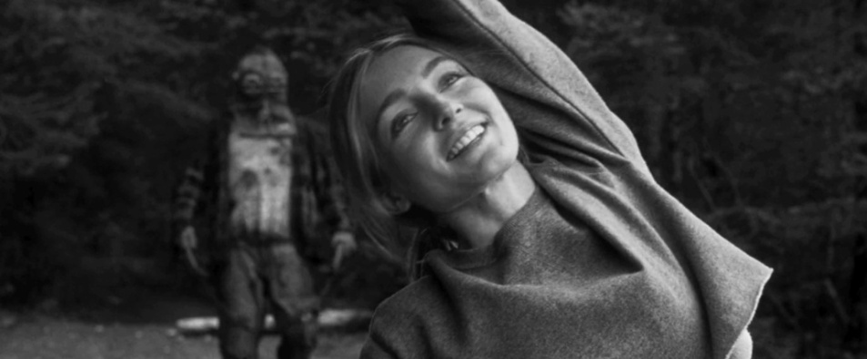

Figure 1: Minion Pro cursiva 9 pt. Alignment centered.  
Source: Author and year, Own elaboration, etc.

Tables must be created in Word and embedded in the document. Each table must have a title and a number.

When you want to include a direct quotation, if it is short (less than 40 words), use inverted commas and keep it within the paragraph, as follows: “Lorem ipsum dolor sit amet, consectetur adipiscing elit” (Surname, year, p. xx). In the case of a long quotation exceeding 40 words, it shall be incorporated in a separate paragraph, separated by a courtesy line at the beginning and at the end, without inverted commas, without changing the typographical format and indented by one digit, in the following way:

Minion Pro regular 8,5. Lorem ipsum dolor sit amet, consectetur adipiscing elit. Maecenas venenatis, enim eget vulputate lobortis, quam leo luctus lorem, sed tristique nisi diam ut urna. Suspendisse non turpis ac erat venenatis porta luctus vitae elit. Nullam luctus nibh a tellus sagittis, sed ornare felis finibus. Sed a nulla at erat cursus congue sed ut quam (Surname, year, p. xx).

This chapter, written in **ENGLISH** or **SPANISH** (Option 3, with Peter Lang), must not exceed **4.000 words** (including footnotes and final bibliographical references). The final publication in the book will be in **ENGLISH**. In the case of submitting the text in Spanish, the translation will be the responsibility of the Congress Editorial Committee, which will make the linguistic and stylistic decisions regarding the translation of the text.

**OTHER TYPOGRAPHICAL RULES:**

**APA 7th Edition** must be followed (<https://apastyle.apa.org/style-grammar-guidelines>).

1. Minion Pro regular 9 pt.
2. Minion Pro regular 9 pt.
3. Minion Pro regular 9 pt.
4. Minion Pro regular 9 pt.